Ideation Phase
Define the Problem Statements

Date | 28 June 2026
Roll Number | 23A51A05L6
Project Name | Automated Network Request Management in ServiceNow
Maximum Marks | 2 Marks

Customer Problem Statement:
Problem  Statement (PS) | I am  (Customer) | I’m trying to | But | Because | Which makes me feel
The Automated Network Request Management in ServiceNow project is designed to streamline and automate the processing of network-related service requests. By utilizing ServiceNow's Service Catalog, Flow Designer, approval workflows, and automation capabilities, the solution minimizes manual intervention and improves operational efficiency. Users can submit network requests through a user-friendly self-service portal, while automated workflows handle request validation, approval routing, task creation, and assignment to the appropriate support teams. Where applicable, the system can integrate with network automation tools to enable end-to-end request fulfillment with minimal human involvement. This automation reduces processing time, enhances SLA compliance, improves service quality, and provides greater visibility and transparency for both end users and IT administrators.
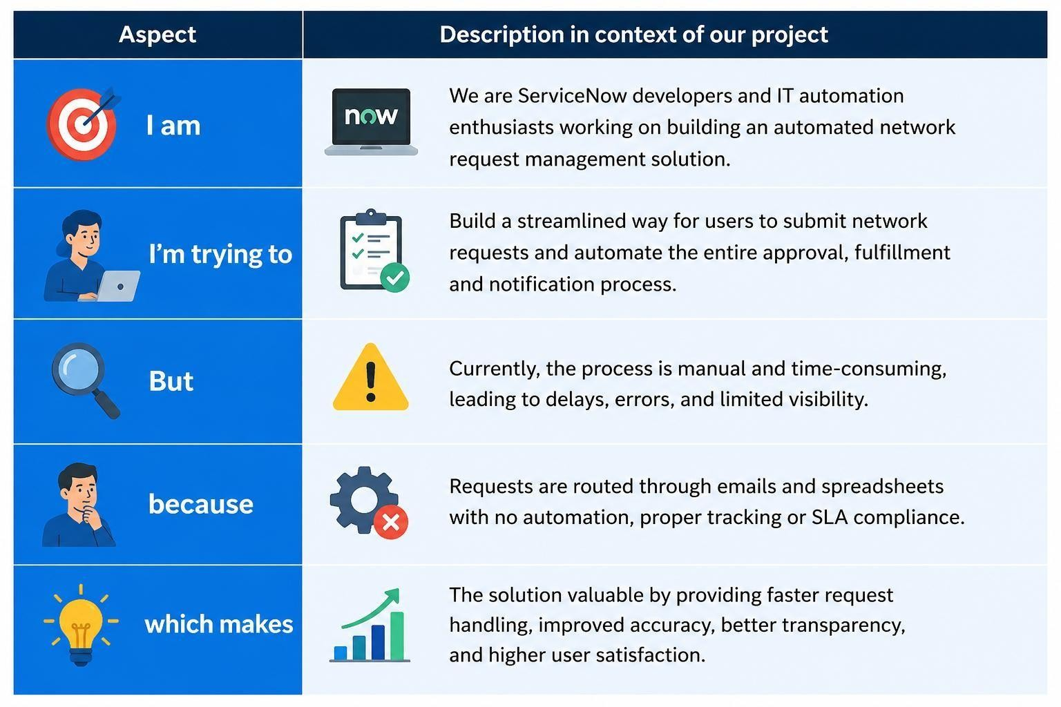
PS-1 | An employee requesting a  network service | Submit a network request quickly and track its status | The approval and request process is slow and requires multiple  manual steps | Requests are handled  manually and lack automation | Frustrated due to  delays and lack of visibility
PS-2 | An IT network administrat  or | Process and fulfil network requests efficiently | Managing approvals  ,  assignme nts, and updates  manually is time-  consumin  g | There is no automated workflow to route and manage  requests | Overloaded and  concerned about meeting  SLA deadlines

